EzAppointment

User Manual

Version: 2.3.0

Release date: 29 April 2014

The contents of this document and its accompanying documents are confidential in nature and shall not be revealed to any party other than the ones it is intended for. The purpose of this document is to provide project specific information to the client. Higher versions of this document shall be created as and when required.

By



Baryons Software Solutions Pvt. Ltd.
39-40, 2nd Floor, 2nd Cross, Govinda Reddy Layout,
Opp MICO Arekere Layout, Bannerghatta Road,
Bangalore, India – 560076
www.baryonssoftsolutions.com

Document Information

Author | Vikas
Reviewer | Harshavardhana K P
Approver | Pranav Kumar
Effective Date | 29 April 2014
File | EzAppointment User Manual.docx

Table of Contents
1.1 Introduction: 3
1.2 Glossary: 3
1.3 Working Flow of This System: 3
2.1 Login: 4
2.2 Super Administrator's Flow : 5
2.2.1 Subscription List 5
2.2.2 Global Settings 7
2.2.3 Business Activation: 7
3.1 Global Search: 8
3.2 Business Owner / Administrator’s Flow: 9
3.2.1 Business Registration 9
3.2.2 Login 9
3.2.3 Global Settings 10
3.2.4 Facility List 10
3.2.5 View Appointments 12
3.2.6 My Profile 13
4.1 Category Description 13
4.2 Business User Registration 15
4.3 Login 16
4.4 My Profile 17
4.5 Appointments 17
5.1 Forgot Password 24
5.2 Change Password 24
5.3 Logout 24

1.1 Introduction:
This document provides the detailed information about the usage and list of services provided by the system. This application is used in appointment systems where user can fix their appointments for their particular needs. Main advantage of this application is that there is no waiting business involved as the users have flexibility to fix their appointments for a particular day for specified time. So, just by going on fixed time, users can avoid waiting and can use their precious time in some other work.

1.2 Glossary:
This part of the documentation describes some of the terms which have an important meaning, and are used throughout this documentation.

- Super Administrator: also designated some times as super admin, is one who maintains this application on baryons portal.

- Business: this term does not need much of explanation as we all know what it means. But, to be clear we can take some of names as example for this term such as lions sports club, sports point, Apollo hospitals, global hospitals, natural beauty care, beauty care center.
Here each term points to some business name.

- Categories: is the term used to categories the related businesses in a group. For example, we can categories the above businesses in three different categories as Sports Clubs, Hospitals and Beauty Parlors.

- Facilities : as name indicates, this term tells about the different facilities provides by different businesses

- Business Owner (Administrator): is one who is the owner of one or more business such as owner of a beauty parlor, sports club, hospital etc.
Here, beauty parlor, sports club and hospital are the different business names. They can also be considered as the categories in which different business may come.

- Business Users: They are the people who make use of these businesses for their needs.

1.3 Working Flow of This System:

Working process of this system can be explained in different flows:
- Super Administrator's Flow
- Business Owner / Administrator's Flow and
- Business User's Flow

Before we start explaining the system's working flow, let us have a look on the home page of this system which could be an easy way to start understanding it. And in order to understand the working flow of the system, this is the start point from where we can start understanding it in a better way.

Have a look on this home page carefully and proceed with the different flows explained below.

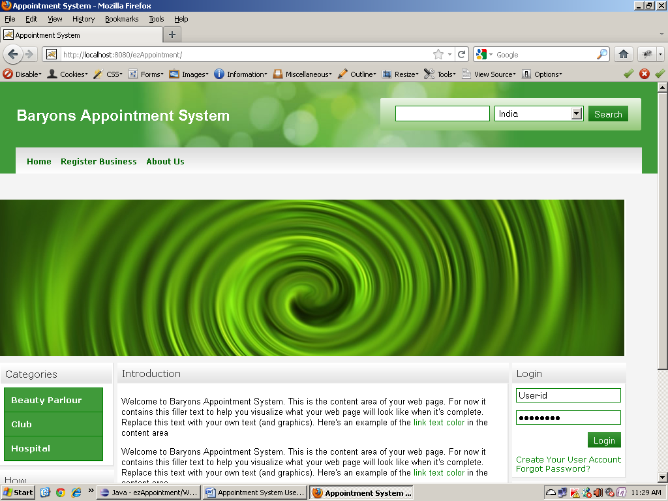

2.1 Login:
Here you will be given with the login details (Username and Password) of super administrator. On the right side of the home page we have a login form where you have to enter the given username and password and click on the button “LOGIN”. If the username and password matches super administrator will be logged in to the system.

2.2 Super Administrator's Flow:

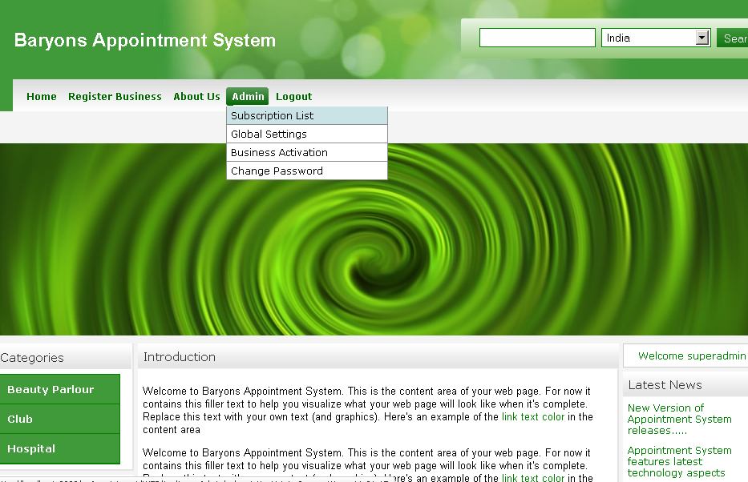

In the above screen, we can the see the admin tab which has a list of tasks maintained by the super administrator. Let us go in detail of these tasks.

2.2.1 Subscription List: On click of this link, we will get a list of all the subscriptions. Here we can search, add, update or delete particular subscription.
Subscription is something which will be fixed by the super admin and are used by the business owner when they are registering their business. Depending on the subscription they select, service will be provided for that subscription period. For example if the business owner selects say “Monthly Subscription” then for a month service will be provided.

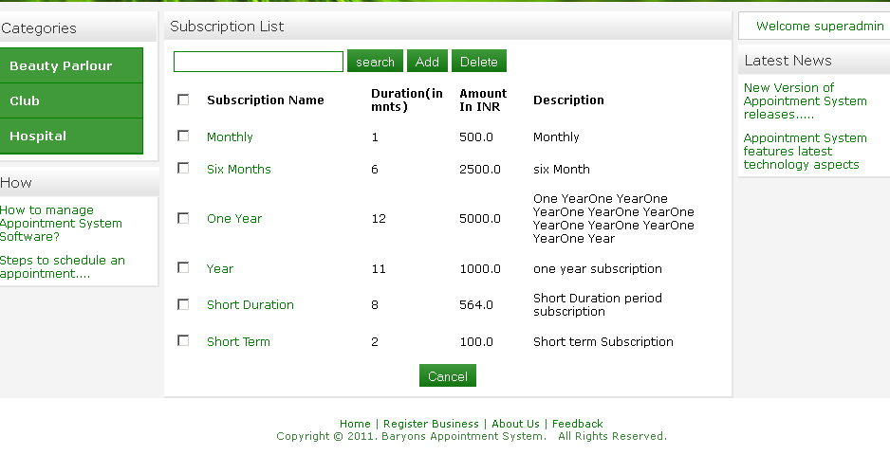

- Subscription Search: Searching subscription is very simple. Just enter the subscription name (or related word or part of the subscription name) in the text box and click on “Search” button. We will get all the related list of subscriptions.

- Add Subscription: To add a subscription, click on “Add” button, and then you will get the following screen.

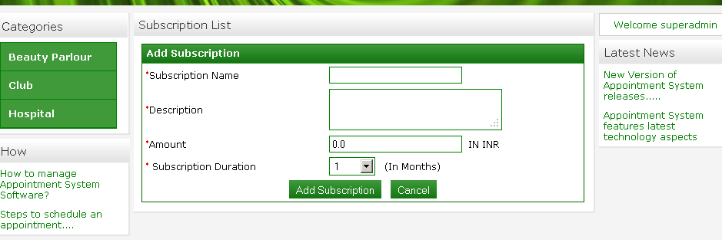
Enter the required fields and click on “Add Subscription” button. Then the subscription will be added to the subscription list.

- Update Subscription: To update the subscription just click on the subscription name link. Then you will get the update screen where you can see all the values pri-filled.

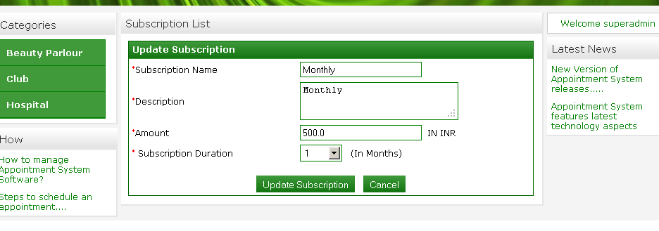
Update the required fields and click on “Update Subscription” button.

- Delete Subscription: To delete, just check the respective check boxes and click on “Delete” button.
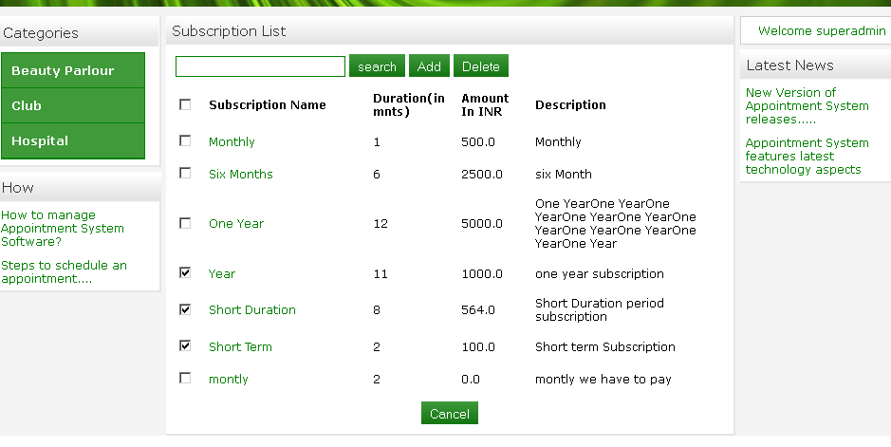

2.2.2 Global Settings:

Click on this link.

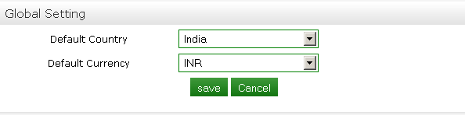

This setting is for setting the related currency code for particular country. Select the country and respective currency then click on “Save button”. Your settings will be saved.
Then the business present in that particular country can only register with the Baryons.

2.2.3 Business Activation: On click of this link you can see all the business who have sent their registration requests. As name says, this is used by super admin in order to activate the businesses. Here business can be searched, activated or deactivated and can also be deleted.

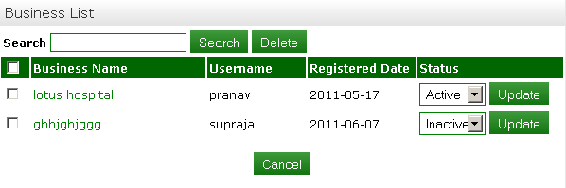

- Business Search: To search a business, just enter the business name (or related word or part of the business name) in the text box and click on “Search” button. We will get all the related list of businesses.

- Business Activation: Depending on certain conditions such as whether the business owner has paid the subscription amount or not, super admin can activate the business. To activate, select the option “Activate” in the select box and click on “Update” button. Then the business will be activated.

- Business Deactivation: Similarly once the subscription period is over super administrator can deactivate the business by selecting the option “Inactive” and click on “Update” button.

- Delete Business: To delete, just check the respective check boxes and click on “Delete” button.

3.1 Global Search: Look at the right corner of the home page; you have a search option with a text box and a select box of country names. This is a country based search i.e. enter some business name and select the country name or just select the country and click on “Search” button. A list of all the business in the selected country will be listed as shown below.

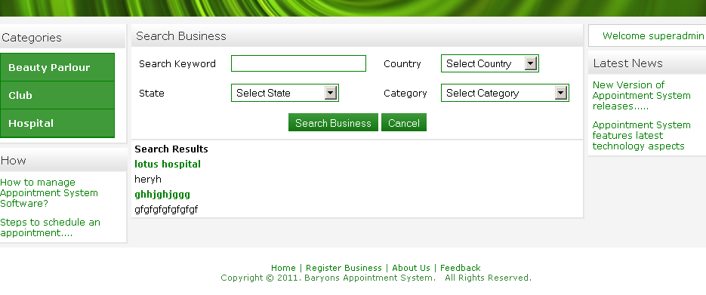

Here you have option to search the business depending on the criteria like country, state and categories.
They can also see all the categories in the left menu. On click of each category you will get a list of all the business present in that category and on click of these business, a list of all facilities under that business will be shown.

3.2 Business Owner / Administrator’s Flow:
3.2.1 Business Registration: To register the business, business owner has to click on the link “Register Business”.
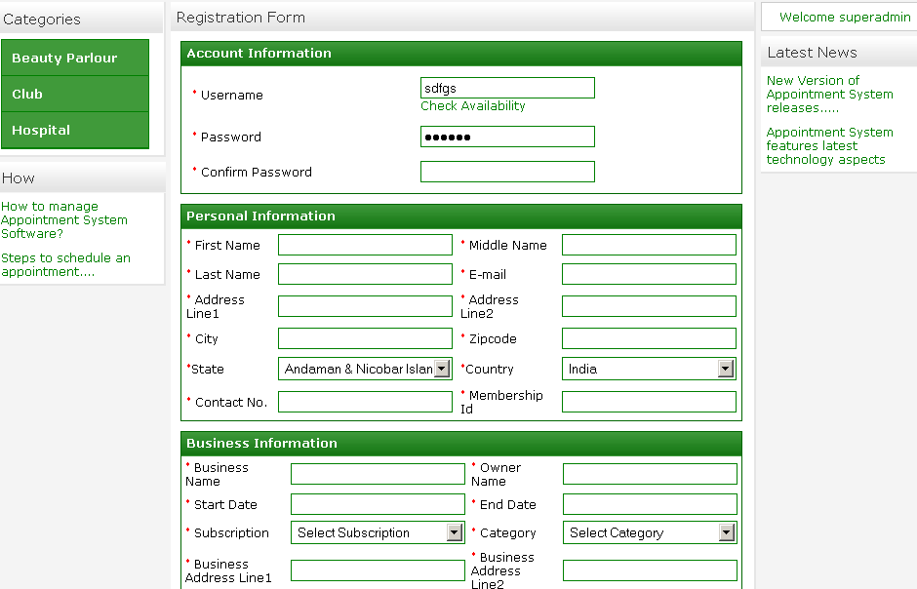
After super administrator activates the business an E-mail will be sent to the business owner which will have the login details (Username and Password). After this, business owner can use these details for their login.

3.2.2 Login: Enter the correct username and password in the login form and login to the system. If the username and password are incorrect an appropriate message will be displayed. You will get this screen when you log in as business owner (or also designated as administrator)
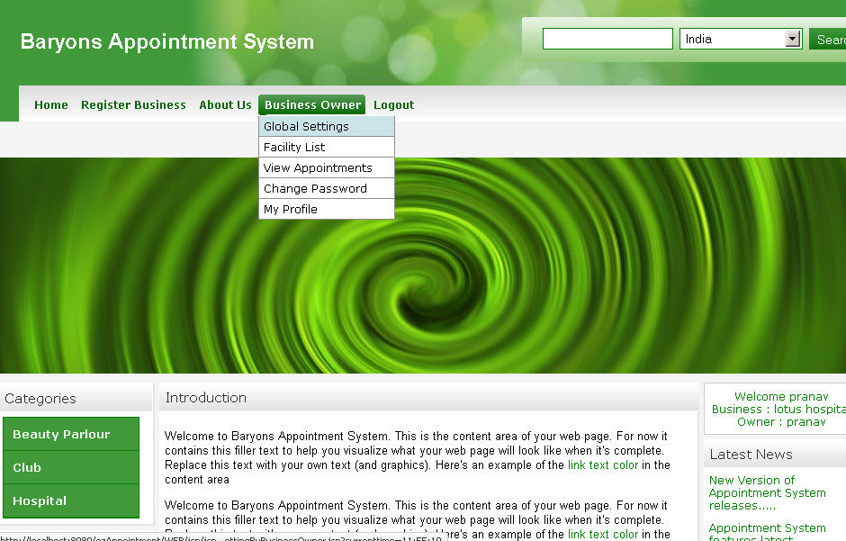

3.2.3 Global Settings: Click on this link.

This setting is for setting the related currency code for particular country. Select the country and respective currency then click on “Save button”. Your setting will be saved.
This setting is done by the business owner for their facilities. That is facilities under the particular business will be available in this country what he/she is setting.

3.2.4 Facility List: Here the business owner can search, add, update or delete the facilities of their business. There are two types of facilities provided. They are:
- Public
- Private.

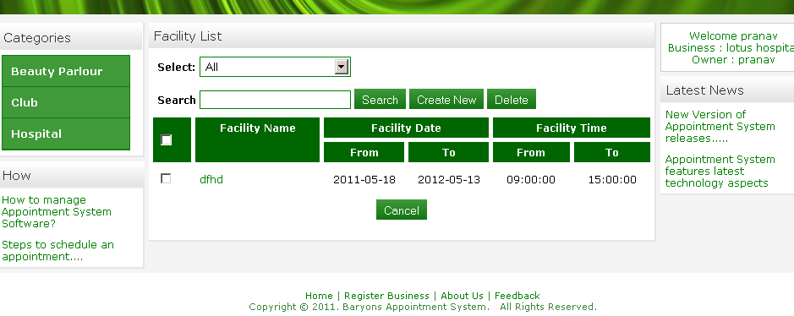

- Facility Search: To search a facility, just enter the facility name (or related word or part of the facility name) in the text box and click on “Search” button. We will get all the related list of facilities. Here you can search on the criteria as public, private or all the facilities.

- Add Facility: To add new facility, click on “Create New” button. After filling all fields correctly, a facility will be added to the facility list.
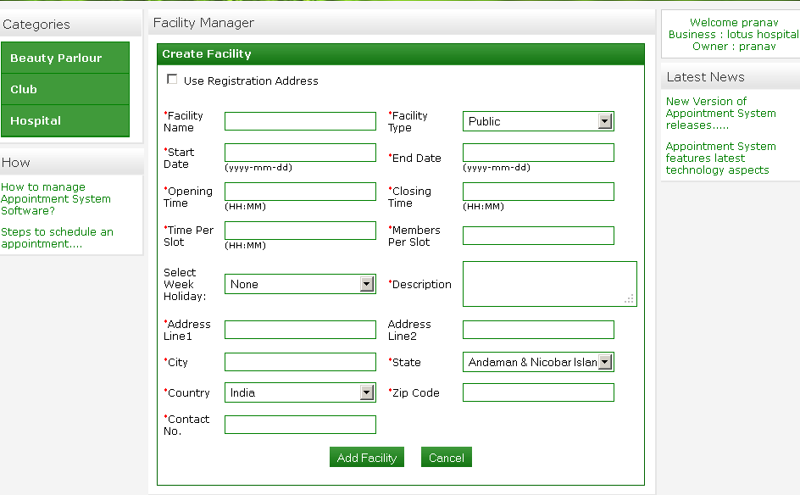

In the above screen, the check box “Use Registration Address” is used to fill up the facility address same as the business address. That is if you check this check box, the address fields will be filled with address details which has been given while registering the business to which that particular facility belongs to.

Member per slot defines the number of members which are allowed for that particular slot. Similarly time per slot is to tell how long a slot can be for this particular facility.

- Update Facility: To update facility, click on the facility name link. Now you will get a screen with pre-filled values. Just update the fields which you want to change and click on “Update Facility” button.
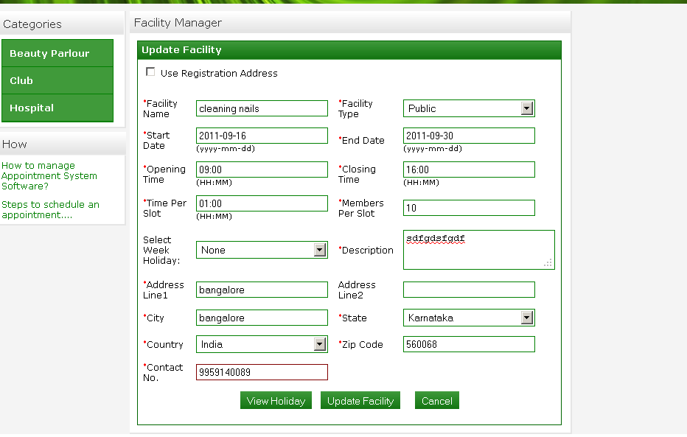

- Delete Facility: To delete, just check the respective check boxes and click on “Delete “button.

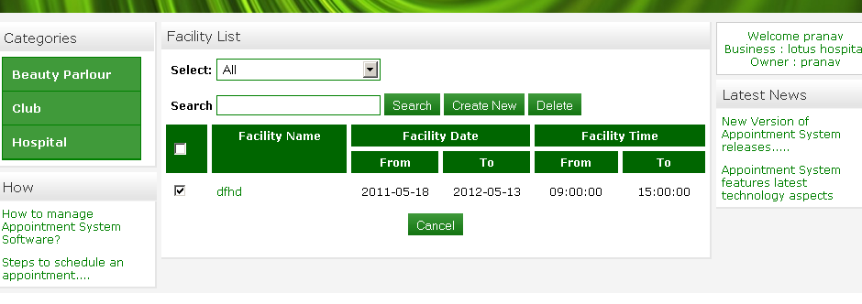

3.2.5 View Appointments: Here, the business owner can view his all appointments and its details as in below screen.

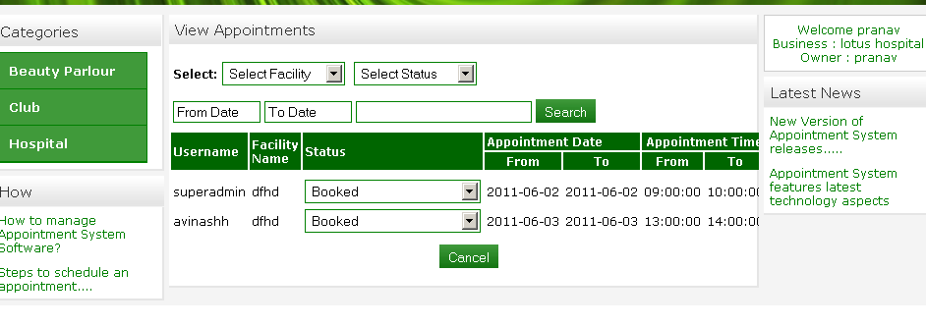

- Appointment Search: The business owner can search for the appointments here depending on different criteria such as appointments facility, its status or it’s from and to dates.

- Update Status: The status of the appointment can also be changed here as from pending to completed, completed to pending or to cancel.

3.2.6 My Profile: This provides the profile of business owner where he/she can change their details.
After changing, click on “Update Profile” button, your details will be saved if you provide correct data else appropriate error message will be displayed.

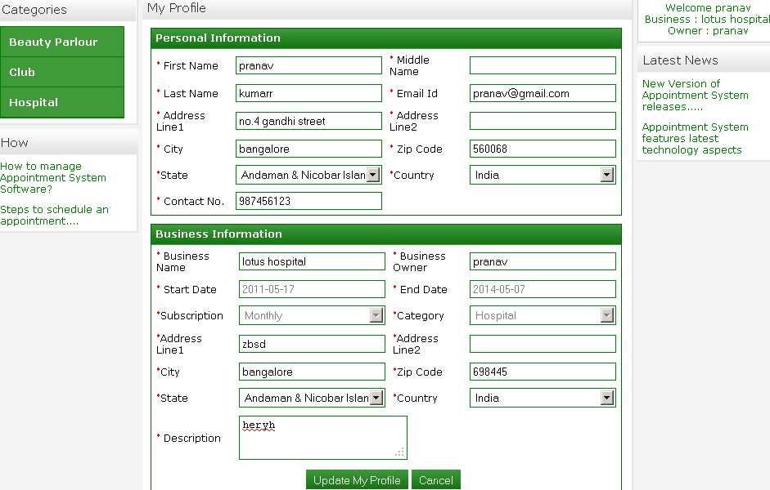

4.1 Category Description: Just have a look on the left menu bar in the following screen which has a list of categories. This list of categories is a start point for the Business Users.

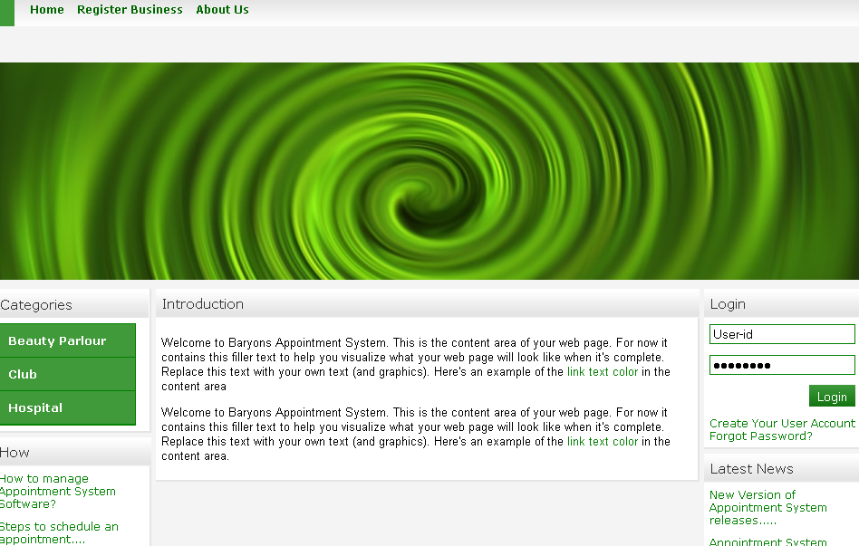

As explained before,
- When we click on these categories, a list of all business under that category will be displayed along with their short description.

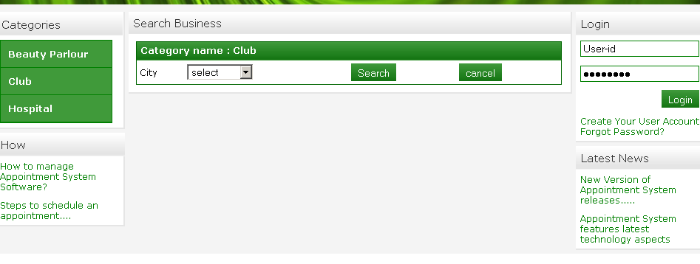

- And on click of these business names, a list of all the facilities will be displayed along with the business details to which the facility belong.
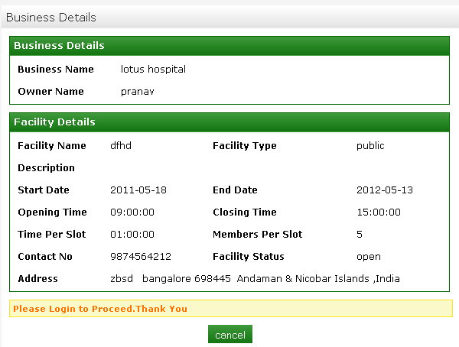

4.2 Business User Registration: This is the link using which the business users can register themselves for the business to which that facility belongs.

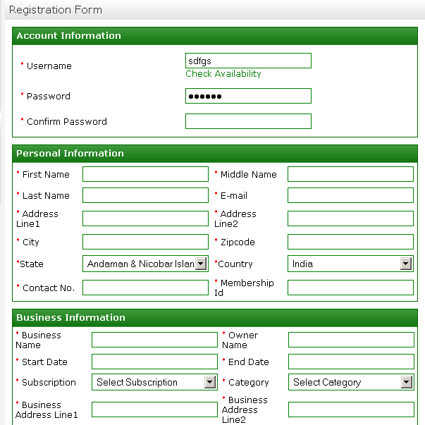

User has to fill all the details correctly and click on button “Register”. If the provided data is correct then the user will be registered to that particular business, else appropriate error message will be displayed. On successful registration an E-mail will be sent to their e-mail id which has the login details (Username and Password).

4.3 Login:
Business users can login to the system using by entering the username and password in the login form. If the username and password matches, user will be logged in to the system else appropriate message will be displayed.

After a business user logs in
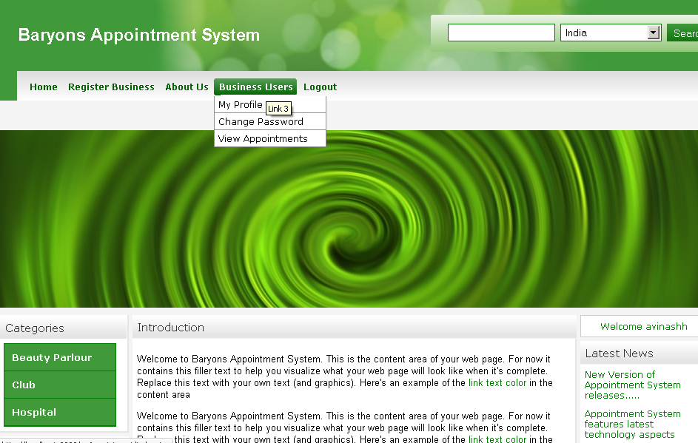

4.4 My Profile:
This provides the profile of business users where he/she can change their details.
After changing, click on “Update Profile” button, your details will be saved if you provide correct data else appropriate error message will be displayed.

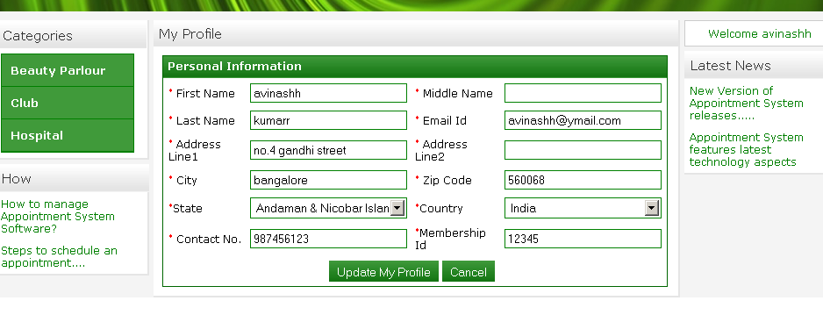

4.5 Appointments: here we will see how to fix or update or cancel an appointment. Understand the following slots before we proceed.
- Available – Slot which is free for you to fix your appointment
- Closed – Slot whose date has been expired and nobody can use this to fix their appointment
- Blocked – Slot which has been booked by some one else, and can not be used by others
- Booked - Slot which has been booked by logged in user, and can be used only by them to update or cancel the fixed appointment.

Blocked and booked are quite confusing. Is it so..? If so then let me clear it for you. Blocked and booked are two different statuses used to mention that, the particular slot is not available to fix the appointment again. As a business user if you fix an appointment say for the date 2009-06-30 from 10:00 to 10:30 then this slot for you will be as “Booked” for other users it will be “Blocked”. Only you can use this slot to update or to cancel your fixed appointment.

Fix Appointment : To fix an appoint, follow the below instructions

Step 1: Click on any of the categories present in the left side menu.

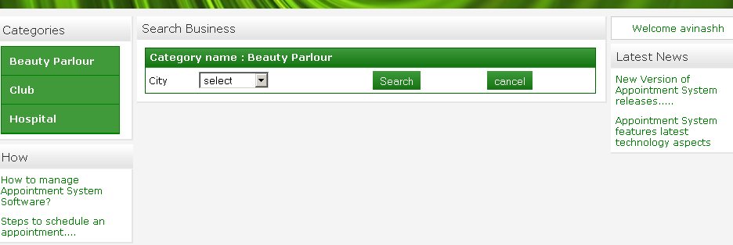

For example, here the selected category is “Club”. After you click on this category you will get a list of all the business of that category.

Step 2: Click on any of the business present in the listed businesses.

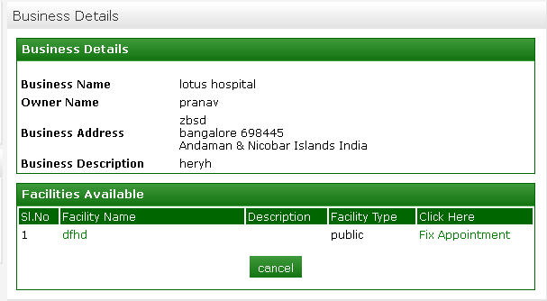

Here you can see the business details of the business which you have clicked and all the facilities under that business. If there is no facility present in the business then an appropriate message will be displayed.

Step 3: Click on the facility to which you want to fix the appointment.
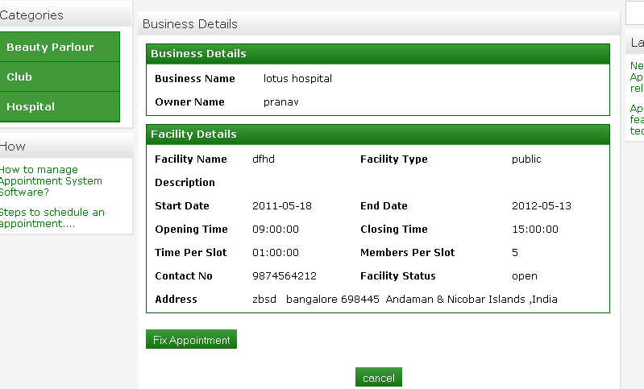

Here you can see the facility details of the facility which you have clicked. The link “Go Back” will take you to the previous page. Now click on the link “Fix Appointment” to proceed.

Step 4: After you click on this link, you will get a screen as below

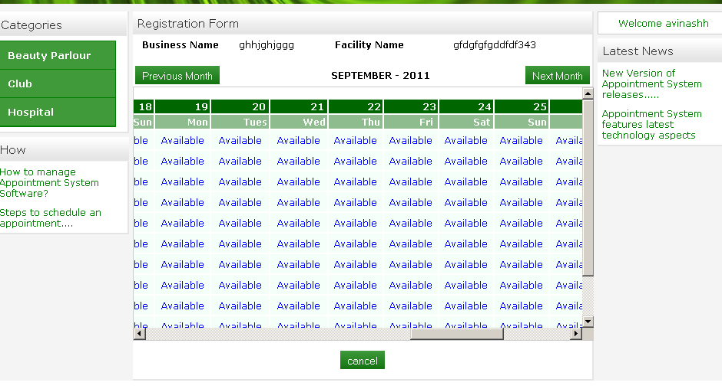
In the above screen you can use the buttons “Previous Month” and “Next Month” to navigate to previous or next months respectively. And can use the horizontal and vertical scroll options too.
The important part of this screen is the horizontal and vertical menu provides.

The horizontal menu shows the dates like 1, 2, 3 etc. and the respective day of that particular Month

The vertical menu shows the time slots of a facility for that particular Day of the month
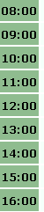

Now click on any slot which is available, to fix your appoint. If you can not see any “Available” slot it means that there is no available slot to fix your appointment. In that case click on “Next Month”.

After you click on the link “Available” you will get the following screen

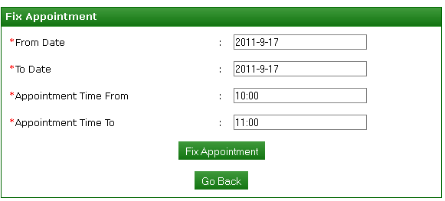

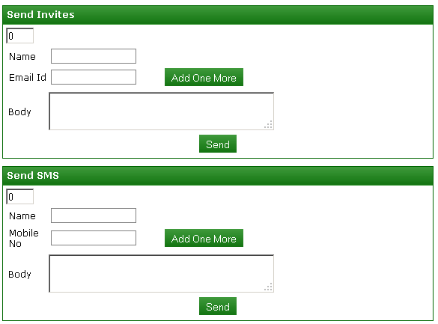

You cannot edit Appointment from Tome and Appointment To Date. It means you can not edit the time slot which you have clicked.

Now select the From Date and To Date.
- If you select start date and end date as the same it means that you are fixing the appointment for only that day at that time.
For Eg: Start date is 2009-06-30 and End Date is 2009-06-30 it means you are fixing the appointment for 2009-06-30 at that time (that slot which you clicked).

- If you select different start date and end date it means that you are fixing the appointment that many days.
For Eg: Start date is 2009-06-30 and End Date is 2009-07-02 it means you are fixing the appointment for 2009-06-30, 2009-07-01, 2009-07-02 at that time (that slot which you clicked).

- “Send Invites” is used to send the invitations for different members through e-mail. Here you can add as many members as you want by clicking on the button “Add One more”. Once you add users you will get a list of users.
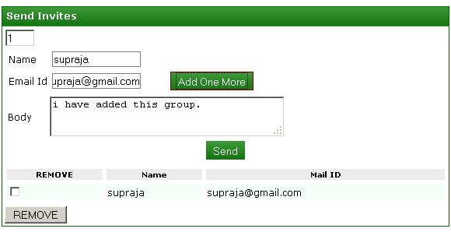

Similarly you can also delete their names from the list. Just select the check box that you want to delete and click on “REMOVE” button.
Finally when you click on the “Send” button, the mail will be sent to all the users present in your list.

- “Send SMS” is used to send the invitations for different members through SMS. Here you can add as many members as you want by clicking on the button “Add One more”. Once you add users you will get a list of users.

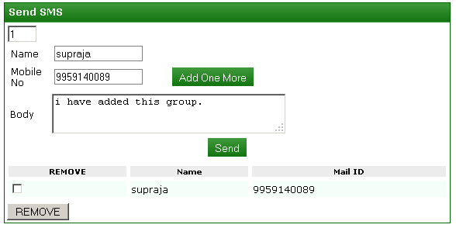

Similarly you can also delete their names from the list. Just select the check box that you want to delete and click on “REMOVE” button.
Finally when you click on the “Send” button, the SMS will be sent to all the users present in your list.

- Cancel Appointment : To cancel an appoint, follow the below instructions

Step 1: First login using your username and password. If you have logged in already then continue with step 2

Step 2: Now click on the category in which you have already fixed your appointment. Then you will get a list of all businesses under it.

Step 3: Then click on the business to which your facility belongs to (facility which you want to cancel).
Step 4: Click on the link “Fix Appointment”. If you have fixed the appointment(s) before, you can see those slots as “Booked” to you.

Step 5: Click on the link “Booked” which you want to cancel. You will get the following screen.

Step 6: Now click on the button “Cancel Appointment”. After clicking on it, the system wii check for the details of this appointment slot.
- For this appointment, if there are no “Send Invites” or “Send SMS” then appointment will be canceled.

- If there are “Send Invites” then first the e-mail will sent to the users.

- And if there “Send SMS” then first the SMS will be sent to the users.

- And if there are both “Send Invites” and “Send SMS” then first the e-mail and SMS respectively will sent to the users.

- After that the fixed appointment will be canceled and the link “Booked” will be changed to “Available” so that other users can use this slot for fixing there appointment.

5.1 Forgot Password:
This facility is used when the user (Super administrator, Business owners or Business users) forgot their password. In such case they can get back their password by requesting here.
Follow the below steps to do this

Step 1: In the right menu, you can see the link called “Forgot Password?” Click on this link. After you click on this you will get the following screen

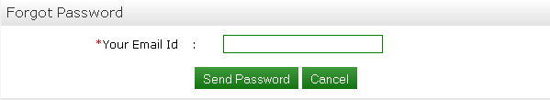

Step 2: Now enter your e-mail id and click on “Send Password” button. If the e-mail id entered by you is incorrect, an appropriate message will be displayed. And If the e-mail id entered by you is correct then an e-mail will be sent to you which will have a machine generated password. Once you get the e-mail, you can use this password to login.

5.2 Change Password:
This is used (if required) to change the password. Enter the current password, new password and confirm password(to confirm the new password) and click the button “Save”, your details will be saved if you provide correct data else appropriate error message will be displayed.

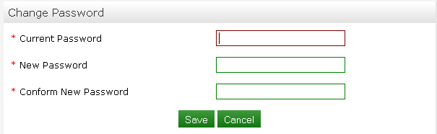

5.3 Logout:

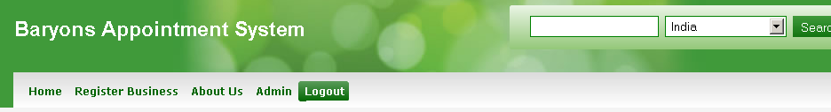
Whether you login as super administrator, business owner or business user, you can see a tab called “Logout” in the menu bar. On click of this tab, you will be logged out of your account and all the sessions data's will be removed from the session.

